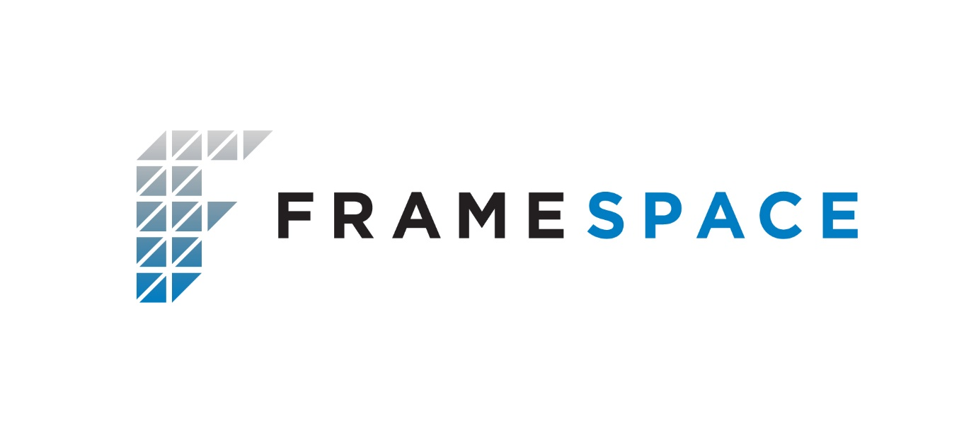

Framespace Solutions Ltd. is Ireland’s leading design, manufacturer and installer of modular Light Gauge Steel (LGS) structures.

Though the utilisation of Modern Methods of Construction (MMC), Framespace provide a more sustainable alternative to traditional forms of construction. With all the major design and engineering inputs completed off-site there is a reduced dependency on ‘wet-trade’ labour and a reduction in programme delivery risk.

Most importantly, Framespace provides an environmentally sustainable solution that dramatically reduces the waste produced in the construction process. All our procedures and systems are in compliance with CE EN1090 & ISO 9001:2015.

Framespace also hold an Agreement Certificate for their MMC system build-up.

